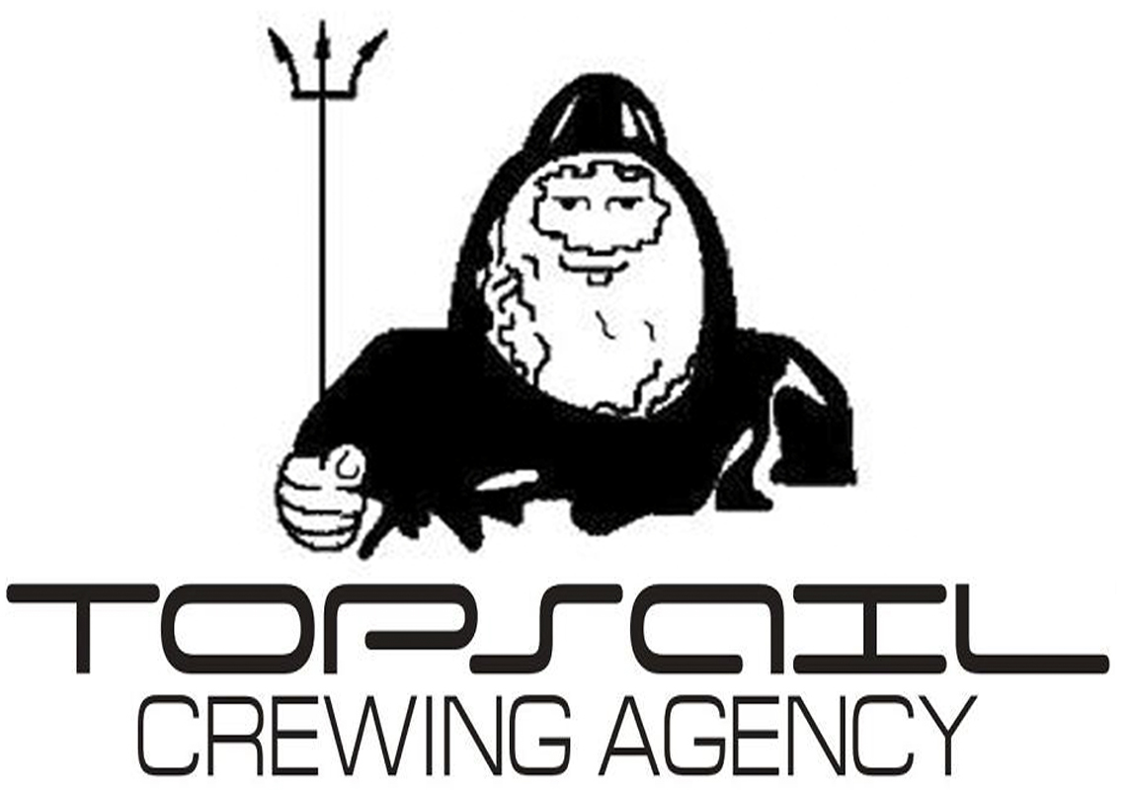  PHOTO | «TOPSAIL» CREWING AGENCY  Kaliningrad, 34, Professora Baranova str.,  “Akropol” business center, office 339  TEL: 8 4012 97 10 45  FAX: 8 4012 97 10 46  EMAIL: info@topsail-crew.com  www.topsail-crew.com  APPLICATION FORM FOR EMPLOYMENT
Position: ___________________ |  | Vessel types: _______________________

DATE OF READINESS: | CONTRACT PERIOD DESIRE: | wages DESIRE: | the nearest airport:
COMMENTS: DON'T FILL THIS COLUMN

Surname, Name, MIDDLE NAME
Date and place of birth, Citizenship
Post code, address of registration
Post code, address of residence
Contact details | Home  | Mobile  |  |  | Contact  |  | E-mail / Skype / ICQ
The marital status (mark X) | single | Married |  |  | separated |  | divorced |  |  | widower
The next of kin, Name and Surname
the address, Post code, telephone
Place of work, position, telephone
Children (name, date of birth)
wife’s name (and maiden name), d.o.b
DATES OF visa expire | USA |  |  | Schengen |  |  |  | OTHERS:

Registered Number of the visa
Educational institutions, the years
Of Graduation and diploma received
FOREIGN languages Knowledge level | English |  | German |  |  | Spanish |  |  | Others:
( SATISFACTORY – GOOD – FLUENTLY )
computer’s skill (mark X) | M/Word |  | m/excel |  |  | Internet

SEA SERVICE FOR THE LAST 9 CONTRACTS
SHIP'STYPE | SHIP'S NAME AND YEAR OF BUILT  CARGO EQUIPMENT (CRANES), CONT TEUs | FLAG | DWT  GRT | ME TYPE  HFO or MDO | HP  KWT | RANK  O/B | Period: from / to |  | SHIPOWNER  CREWING
 |  |  |  |  |  |  | DD/MM/YY | DD/MM/YY | SHIPOWNER  CREWING

LIST OF THE DOCUMENTS AND CERTIFICATES
Documents | Number | Issuing Date and country |  | Date of exp.
Licence (national) / grade:
Licence (Any other) / GRADE:
Licence (Any other) / GRADE:
Passport Seaman’s
Passport Travelling
Passport (Any other)
Seaman’s book (Any other)
Seaman’s book (Any other)
Oil TANKER endorsement
chemical TANKER endorsement
gas TANKER endorsement
Oil Tanker Familiarization TRAINING course
Chemical Tanker Familiarization TRAINING course
Gas Tanker Familiarization TRAINING course
Oil TANKER specialized training program
chemical TANKER specialized training program
gas TANKER specialized training program
Crude oil washing operations, inert gas system
Ships carrying dangerous and hazardous cargoes
GMDSS GENERAL operator
GMDSS GENERAL operator Endorsement
ROP (RLT)
ARPA
Personal survival techniques, fire prevention AND Firefighting,
elementary first aid, personal safety and social Responsibility
Proficiency in survival craft and rescue boats
Advanced fire-fighting
Medical care course
Medical first-aid
SSO - Ship security officer
SSS - Ship security staff
Bridge / engine team management
Maneuvering & ship handling
electronic charts
ISM Code
AIS
Certificate of health
Vaccination / Re vaccination against yellow fever

APPEARANCE AND CUSTOMIZED FIELDS
Height |  | Overall |  | Color of eyes |  | Head size
Weight |  | Shoes |  | Color of hair |  | Complexion
distinguishing marks (Scars, tattoos etc.)

The sailing area you are mainly experienced :

nationality of crew you have worked with :
REFERENCES: |  | RANK |  | NAME | The address | Phone / Fax / mobile
Shipowner
ship manager
ship's name |  | MASTER (C/E)

DATE: SEAFARER'S NAME: SIGNATURE:

