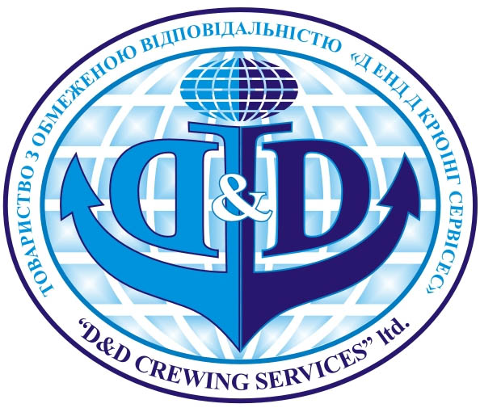
PERSONAL APPLICATION FORM

Position applied for:

Personal data
Name
Date of birth |  |  |  |  | Place of birth |  | UKRAINE |  | Nationality |  | UKRAINIAN
Marital status |  |  |  | Address |  | UKRAINE |  |  |  | Tel
Next of kin |  |  |  |  |  |  | Address | SAME
Pre-sea education
Document № Date and place of issue Expiry date

Seaman’s book
Civil Travel Passport
Ukrainian Passport
Liberian seaman’s book
Panama seaman’s book

USA visa C1/D

Medical certificate Date of issue Expiry date
Yellow fever |  |  | Height, cm: | Weight, kg:
Medical test |  |  | Colour of Eyes: | Colour of Hair:
Drug and Alcohol test |  |  | Size: | Shoes:
STCW Certificates
 | Grade | Certif. № | Date and place of issue | Expiry date
Certificate of competency
Endorsement
Up-grading courses
GMDSS (endorsement)
Radar simul. and observ.
A.R.P.A.
Basic Safety Training, PSSR
Advanced fire fighting
Medical first aid
Medical care
Prof. in survival craft
Ship Safety Officer
Ship Security Officer
Bridge Team Management
Dangerous goods
Additional courses attended (STCW Certificates)
Liquefied Gas tanker
Chemical tanker
Oil tanker
Other certificates of Competency held
Liberian COC
Panamanian COC
SEA SERVICE
Fm | To | Ship’s name | Vssl type/ DWT | Type of engine/BHP | Flag | Company | Rank

FOR TANKER VESSEL. Cargo information sheet (please tick the appropriate box) :
Acrylo-nytrit | Pentene | Nitric acid | Phosphoric acid | Ethylene | Caustic soda | Hep-tane | Xyle-  nol | Palm oil | Tolu-ene | Meta-  nol | VegOil | Steorin
Other cargo carriage:
Nationalities of crews sailed with: Trading areas : WW
ENGLISH ABILITY | Good | ISM knowledge | GOOD | SMS knowledge | GOOD

