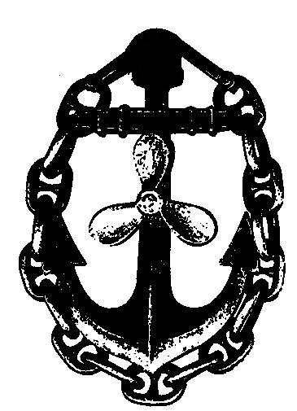 | ANDREY TIKHONENKO FIRM  SEAMEN CREWING AGENCY  139 NEMUNO STR. ROOM 104. LT-93262 , KLAIPEDA, LITHUANIA  TEL/FAX: (+370) 46 380618,  mob. +370 687 81684, +370 686 60479  E- mail: A.Tikhonenko@takas.lt

APPLICATION FORM FOR EMPLOYMENT
Full Name: |  | Citizenship: |  | Rank:
Birth date/place: |  | Address: |  | Phone:
Marital status: | Wife: |  | # of Children: | Mob. Ph.
Name / address of Next-of-kin: |  |  |  | E-mail:

Passport #: |  | Date/Place of issue: |  | Valid till:
Seaman's book #: |  | Date/Place of issue: |  | Valid till:
Seaman's book #: |  | Date/Place of issue: |  | Valid till:
Seaman's book #: |  | Date/Place of issue: |  | Valid till:
Visa:
Health Certificate #: |  | Date/Place of issue: |  | Valid till:
Height: | Weight: |  | Clothes size: |  | Shoes size:
Education:
License:
Languages English: Other:
Professional courses / seaman's certificates
Courses: | STCW CODE | Nr.: | Issue: | Valid:
GMDSS GENERAL OPERATOR | IV/2
PERSONAL SURVIVAL (SOLAS) | VI/1
SURVIVAL CRAFT | VI/2
ADVANCED FIRE FIGHTING | VI/3
ARPA | I/12
RADAR OBSERVATION AND PLOTTING | I/12
MEDICAL FIRST AID | VI/4
MEDICAL CARE | VI/4
SHIP SECURITY OFFICER | XI-2
TANKER CERTIFICATE
OTHER
Details of sea service (last 5 years or last 5 ships)
# | Ship's name/Flag | DWT | M.E. Type/hp | Ship's Type * | Rank | Service period  s-on / s-off |  | Owner's name
1
2
3
4
5
6

Date: ……………… Signature: ………………..

